
Chapter 11
POST CARE & RELAPSE PREVENTION

Celebrate What’s Right with the World
Believe it and you’ll see it.
Nature is abundant.
There are countless possibilities
Great is millimeters, not miles.
When you weave, weave.
Be your best for the world.
Focus on what’s right to unleash your energy to fix what’s wrong.
by Dewitt Jones

11. POST CARE & RELAPSE PREVENTION
11.1 Navigating Change Successfully
11.2 Values Clarification- Building Creditability
11.3 What Stage are you at Now?
11.4 Future Life Choices
11.5 Community Welcome Home
11.6 Treatment to the Community
11.7 The Relapse Process
11.8 Coping Tools for Relapse
11.9 Balanced Lifestyle and Positive Addiction
11.10 Relearning Positive Lifestyles
11.11 Facilitate Termination Process

11.1 Navigating Change Successfully
Every successful transition starts with awareness. As your client becomes more aware, they lose their vagueness about self, their values and their life situation and they become available to the moment and to their experience. Their experience is the here-and-now internal state that they continuously create from internal and external sensory information that consists of:
1. Their feelings (mad, sad, glad, scared, envious, etc.)
2. Their thoughts (judgements, beliefs, interpretations, assumptions, etc.)
3. Their intentions (motives, wants, desires).
Their experience is dynamic. They are changing with each instant of their lives. For the most part, they miss this experience by:
- Living in the past
- Living in the future.
- Focusing outside them.
The “formula” to successfully move them through their transition is:
Awareness + Acceptance + Action = Change
Step 1: Awareness: Life Choices
Do we choose our own thoughts, behaviours, feelings and consequences? Or are we just seeds, being blown by the winds of life? Or is there a middle ground where we recognize that we make choices that impact our life experiences. As one proceeds through a wellness process for their addictions, they gain insight toward their own sense of self determination for the rest of their life. To help your client develop insight and awareness of their life choices an exercise has been developed to show how much control they had or took regarding their life. Research shows that clients with a high sense of self determination also have greater health.
Step 2: Acceptance of Self
After completing the Life Choices scale, your client should be more aware of their choices and how much personal power they owned and allowed someone/thing to control them. The next step is reflective thinking about what they have learned from completing step 1. By discussing with your client what they have learned about their past life choices, what needs to happen will become apparent to them.

Step 3: Action for Self
Research states that when a client writes out an action plan, they are more inclined to follow through with their plan. Discuss the follow items with your client to find out where they are and where they want to go with their life.
Awareness: Life Choice Scale
Most often clients do not realize that they are in control of their life and their life choices affect their life. Below is a Life Choice Scale to assist with determining where your client is at, where they want to be and where they require more assistance in determining how much personal control they have in their life. By teaching your client Life Choice modeling skills that empowers them to say what they want and helps to decide how much they’re willing to contribute, personally, to making it happen.
Rating
1= somewhat feels true
2= feels true
3=moderately feels true
4= feels very true
5=strongly feels true

A blank copy of the Life Choices Scale is located in Appendix Z.

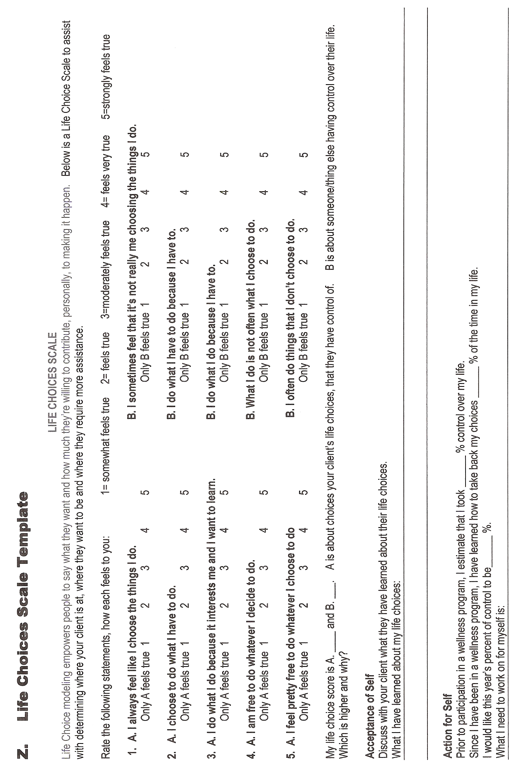
11.2 Values Clarification-Building Credibility
Being aware of one’s personal values makes a difference in your client’s behavior with family, friends and their community. Values are guides to action that can help your client build their credibility. Credibility building is a process that takes time, hard work, devotion and patience. Coming back into a family or group within the community can also be very trying - there’s more skepticism about their intention and their abilities.
Values are empowering. They are much more in control in their own personal lives when they are clear about their personal values. When your client’s values are clear, they don’t have to rely on direction from someone in authority (you). By knowing what means and ends are most important, they can act independently. Also, they can recognize when there are conflicts between their own values and those of their family, friends or community and they can exercise choice about how to respond.
Research states that the people that have the highest degree of commitment to change are those that have the greatest clarity about both personal and community values.
What values does your client live by?
Discuss the following values with your client, so they will have direction and know where they stand and why, when they need empowering.
Do they have Universal Values?

honesty
respect
responsibility
fairness (justice)
compassion (love)

Or does your client follow the 7 Anishnaabe Grandfather Teachings or some other teachings?
To cherish knowledge is to know Wisdom
To know Love is to know peace.
To honour all of Creation is to have Respect.

Bravery is to face the foe with integrity.
Honesty in facing a situation is to be brave.
Humility is to know you as a sacred part of Creation.
Truth is to know all these things.
Author unknown

Values Clarification Steps:
When your client is clear about the values that they stand for and believe in, the creditable they become. The following questions can use as a guide to clarify your client’s values.
- Write a Tribute to Yourself
- What do you stand for? Why?
- What do you believe in? Why?
- What are you discontent about? Why?
- What brings you suffering? Why?
- What makes you weep and wail? Why?
- What makes you jump for joy? Why?
- What are you passionate about? Why?
- What keeps you awake at night? Why?
- What grabbed hold and won’t let go? Why?
- What do you want for your life? Why?
- Just what is it that you really care about? Why?

- Who has been their historical leader, mentor or role model in their life? Discuss the following questions to elicit the foundation of their values and how their values are modeled.
- Which historical leaders do you most admire? Why?
- What values did they espouse and practice?
- How will these values show up in your own actions?
- Make a list of the individuals in your own life who’ve served as your values models.
- What values did they espouse and practice?
- How will these values show up in your own actions?

- When your client is clear, concise and action driven with aligning their actions with their values; the more empowered and creditable they become. At this stage, have your client list their value and how they will show their value to those that they may have hurt or offended in their past. When they being to create opportunities for change, then they are putting their thoughts into actions.
- Make a list actions that you will demonstrate your values
- What other ways can you “role model” your values
- What opportunities will you create for yourself to speak about your shared values with enthusiasm and confidence? (fill in chart below)
Values Clarification Chart:
Value | How are you showing value | Opportunities created
honesty

A blank copy of this chart is located in ‘Appendix ZA
11.3 What Stage are You at Now?
Ask your client to think about where they are at by bringing your client back through each stage in detail, asking for comments on how they have moved to the next stage, what is the “evidence” to show they are at a certain stage.
Precontemplation: The precontemplation stage is that time when your clients who do have a substance problem are not convinced that they have a problem or that substance abuse is the least of their problems, and they are not willing to consider change.
Contemplation: At this stage, your client with the substance abuse problem is actively considering the possibility of change. Clients in this stage are evaluating options but they are not ready to take action.
Preparation: In the preparation stage, your client makes a commitment, as well as, prepares initial plans to take immediate action.
Action: Once your client begins to take action to remedy their problem, they are considered to be in the action stage of change. Your client is either abstinent or managing to significantly reduce his or her use and is not getting high when using. At this stage, your client is also adopting strategies to prevent a relapse and a return to the problem behaviour.
Maintenance: The maintenance stage of change is one in which your client stabilizes the changes he or she has made and integrates them into his or her lifestyle.

Conduct a Stage Exercise
As their counsellor, you have been paying attention as to how your client has progressed, during the course of their wellness program. Ask them to think about whether they feel they have moved forward or stayed “about the same” in terms of their alcohol/drug use. Ask your client to look at each stage again, as you describe it and determine their own current stage. Discuss this stage exercise with your client. Is their stage different now, than it was earlier in their wellness program?

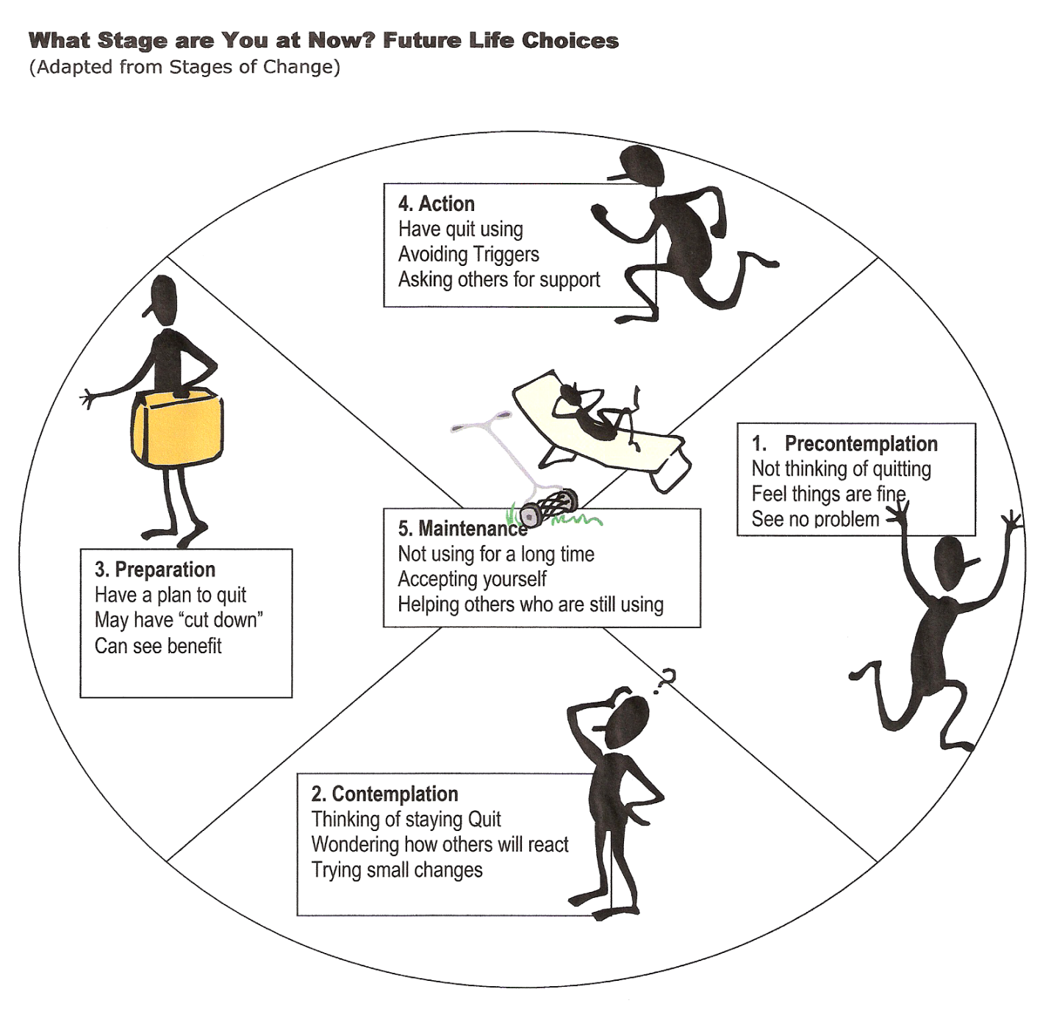

11.4 Future Life Choices
By providing your client with choices as to what and how their needs are being met, they feel empowered and in control of their future life. The following chart is a review of your client's mental, emotional, physical, spiritual, cultural, family, community, substance use and activity/occupational needs and future life choices. The subtitles are prompt suggestions for discussion purposes and may not be required for every client. This chart can be an ongoing process from their initial visit to termination with your client. This chart ensures that all your client’s needs are being met and that you are supporting them in their life choice process but not expected to deliver all of their needs.
Discuss your client’s future choices, their commitment to immediate, short and long term goals. What resources will they require? Who will provide these resources? How will they reward themselves when they reach their goal?
A blank copy of this chart is located in ‘Appendix ZB.
11.5 Community Welcome Home
The best way to celebrate one's return from treatment is with a community welcome home party. Surrounding a client with love, acknowledgement, acceptance and joy is the perfect community welcome home message that removes the stigma of shame, guilt and blame that often accompanies substance abuse.
How to Prepare
Prepare for a community welcome home party by thinking about the situation which your client has been working on; as substance abuse comes with an assortment of other factors- loss of family, friends, and community connection. Each client’s scenario can play a huge factor on the type of party you provide and how your client reintegrates back into the community.
Invitations, decorations, refreshments, Honour song, social dancing and a certificate of achievement signed by chief and council to honour this stage of change with presents can make your community welcome home party a success. Do be mindful of your client's situation, and tone down the celebration where applicable, such as the client may be tired and in need of a much-deserved rest. The community welcome home party shouldn't go over two hours.
A welcome home party is a community affair where all community members are invited. This makes the client feel special by being the center of attention, especially in the case of a surprise party and provides an opportunity to speak to all members of the community. A community welcome home party is more meaningful when it is to honour the work and commitment for change that is celebrated by loved ones, friends and community members.
State: “The gift you have given yourself is you and your health. You have faced many fears and used your courage to look at life in a different way..........” Provide an opportunity for you, family, friends and community members to congratulate your client on his/her success in completing a treatment program; as not everyone has the courage to face their substance abuse issues and make plans for change.
Sending Out Invitations
Send invitations out at least two to three weeks in advance of the party.
Decorating for the Event
Decorations should include balloons, streamers and banners. You can draw from your client's recent experience, with pictures or a video of before and after treatment. You could use the client’s favourite/personal colours for the colour theme of the tablecloth, utensils and paper goods.
Refreshments to Serve
Take note of your client's favourite foods or feast foods and make sure these items are on your food list. Finger foods are another good idea. A cake is a big hit at any party. Try to make the theme of the cake, match the client’s Anishnaabe name/clan/character. Use your imagination, and make the cake a memorable part of the day. Don't forget to take pictures of the cake before it is cut.
Clean-Up Suggestions
Make sure that you are not leaving a mess behind for your client to have to clean up. Consider serving on paper plates and in plastic cups. This will make your job of cleaning up simple. Also be sure to recruit a few guests to help you with the clean-up.

11.6 Relapse Prevention
A relapse prevention plan is an important component of wellness for a substance user. The Relapse Prevention model suggests that immediate factors such as (e.g., high-risk situations, coping skills, outcome expectancies, and the abstinence violation effect) and hidden factors of lifestyle, urges and cravings can contribute to your client’s relapse. A Relapse Prevention Plan needs to incorporate a number of specific intervention strategies that allow the counsellor and your client to address at each step of their relapse process. Intervention includes culture reconnection, identifying specific high-risk situations for your client and enhancing your client's skills for coping with those situations, increasing your client's self management, eliminating their beliefs regarding substance abuse effects, managing slips (lapses), and changing your client's perceptions of the relapse process. Strategies that assist with balancing your client's lifestyle with helping them to develop positive addictions choices, implementing self control techniques and urge/self management techniques, and developing a relapse road map to stay on their healing pathway are required.
Community resources provide support, caring, and acceptance to someone who is attempting to make a change and are needed for both the client and caregiver. A support network of a number of people who are in some way connected to the client that provides him/her with various spiritual, mental, emotional, social and practical types of support. Identify with your client, their existing and potential social support networks and as they become more aware of the current and potential helping relationships in their lives. It is also important for these helpees to acknowledge that it is their responsibility to ask for support too. They should not wait for others to anticipate their needs; instead, your client is taught the importance of being supportive to others too by volunteering. Explain that helping relationships are important in making and maintaining behaviour changes. Stress that these relationship networks are frequently in place, but many people have difficulty in identifying them. Then tell them that, because people with substance abuse problems often can’t identify the helpers available to them. Discuss the idea that asking for help is not a sign of weakness. Explain to the group that the belief many people have grown up with is that it is shameful or “not okay” to ask for help. A more mature, practical way of looking at this is that it will help the client to achieve their goals. While some people may feel that they can “go it alone,” we maximize our chances for success when we include others as resources in our network of support.
Make the analogy of a spider web with many different directions and links, if we dsign a social support web, we are somewhat protected.

Relapse, or the return to substance use following a period of abstinence or moderate use, occurs in many users who have undergone treatment. Traditionally, treatment approaches often viewed relapse as a negative outcome; meaning that your client’s treatment program had failed. As a result, your client’s belief was that their treatment outcome--was either abstinent or relapsed. However, other treatment models of relapse that are based on different theories view relapse as a transitional process or a series of events that unfold over time, (Annis 1986; Litman er al. 1979; Marlatt and Gordon 1985). According to these models, the relapse process begins prior to the first post treatment use and continues after the initial use. These concepts provide a broader framework for intervening in the relapse process to prevent or reduce relapse episodes and improving positive treatment outcomes.
* Negative emotional states, such as anger, anxiety, depression, frustration, and boredom, which are referred to as high-risk situations, are associated with the highest rate of relapse (Marlatt and Gordon 1985). These emotional states may be caused by certain situations (feeling bored or lonely after coming home from activities/work to an empty house) or by reactions to environmental events (feeling angry about an event at work/divorce/loss).
* Situations that involve another person or a group of people in high-risk situations, like interpersonal conflict (an argument with a family member), result in negative emotions and can cause relapse. Negative emotional states and interpersonal conflict situations served as triggers for more than one-half of all relapse episodes in Marlatt's (1996) analysis.
* Social pressure, including both direct verbal (come on let’s go and smoke a joint) or nonverbal persuasion (being around other people who are using), contributed to more than 20 percent of relapse episodes in this same study.
* Positive emotional states (partying), exposure to substance related situations or cues (seeing an advertisement for an alcoholic beverage or passing by one's favourite bar), testing one's personal control (using "willpower" to limit consumption), and nonspecific cravings also were identified as high-risk situations that could encourage relapse

Relapse Warning Signs:
1. Apprehension About Well-Being – lack of confidence to remain sober
2. Denial – lying to themselves to cope with day to day problems
3. Adamant Commitment to Sobriety – convince themselves that they will never drink again
4. Compulsive Attempts To Impose Sobriety on Others – focusing on what others do
5. Defensiveness – defends themselves when talking about problems
6. Compulsive Behavior – behavior becomes rigid and repetitive)
7. Impulsive Behavior – overreactions to episodes of stress
8. Tendencies Towards Loneliness – patterns of isolation and avoidance increase
9. Tunnel Vision – Clients view their lives in isolated fragments
10. Minor Depression – Symptoms of depression appear and persist
11. Loss of Constructive Planning – life planning skills decrease
12. Plans Begin to Fail – follow through no longer happens
13. Idle Daydreaming and Wishful thinking – concentration begins to be replaced with fantasy
14. Feeling That Nothing Can Be Solved – I can’t do anything right
15. Immature Wish To Be Happy – vague thought patterns of just wishing to be happy, no planning on the “How”
16. Periods Of Confusion – episodes of confusion increase
17. Irritation With Friends – positive relationships become strained
18. Easily Angered - angry overreaction becomes more frequent
19. Irregular Eating Habits – client begins overeating or under eating
20. Listlessness – inability to initiate actions
21. Irregular Sleeping Habits – lack of sleep or over sleeping
22. Progressive Loss Of Daily Structure – daily routines become haphazard
23. Periods of Deep Depression – symptoms become more severe and frequent
24. Irregular Attendance At Treatment Meetings – missed appointments or no attendance
25. Development of An “I Don’t Care” Attitude- feelings of helplessness
26. Open Rejection Of Help – clients cut themselves of from help sources
27. Dissatisfaction With Life – things are bad I might as well use again
28. Feelings Of Powerlessness And Helplessness – distorted judgement and impairment
29. Self-Pity – Poor Little Old Me
30. Thoughts of Social Drinking – client feels that they could control some use
31. Conscious Lying – begin lying to themselves in hopes of believing everything is O.K.
32. Complete Loss of Self-Confidence – overwhelmed by inability to think clearly
33. Unreasonable Resentments-unreasonable anger at the world and self
34. Discontinuing All Treatment – attendance at meetings stops completely
35. Overwhelming Loneliness, Frustration, Anger and Tension – feelings of total overwhelm
36. Start of Controlled Drinking- beginning of use somewhat controlled by time or amount
37. Loss of Control – a return to drug and alcohol use and abandoning reasoning
11. 7 Coping Tools for Relapse
Despite all the precautions and preparations, many clients committed to abstinence will experience a slip (lapse) after initiating their abstinence. Slip management strategies focused on stopping the slip and understanding the abstinence violation effect to prevent an uncontrolled relapse episode are required. Slip management involves contracting with your client to limit their extent of use, to contact their counsellor as soon as possible after their slip, and to evaluate the situation for clues as to the factors that triggered their slip. Provide your client with simple written instructions to refer to in the event of a slip. Your instructions should describe the importance of stopping their substance use and safely leaving the slip including the situation. Slip management can be presented to your client as an "emergency preparedness" kit for their healing journey to abstinence. Many clients may never need to use their slip management plan, but preparation can greatly reduce their harm if a slip does occur.
Imagine that you have a slip, that is, you have a drink or take an extra prescribed, an over-the-counter pill or other substance.

Relapse Plan with Emergency Procedures
1. What should you do? List as many steps as you can.
______________________________________________________________________
______________________________________________________________________
______________________________________________________________________
2. What should you not do? List as many steps as you can.
______________________________________________________________________
______________________________________________________________________
______________________________________________________________________
3. If one of the steps you listed in question 1 was to call someone,
a. What is the person’s name? ______________________________
b. What is the person’s phone number? _______________________
4. Relapse Contract to limit extent of use
3What to do if a slip occurs:
Stop, Look, Listen and Feel
Keep Calm- Tell yourself you can stop
Renew Your Commitment- Leave the situation, get rid of the substance, or hand over your prescribed medications to a trusted family member or friend who will monitor your use.
Implement your Relapse Prevention plan
Call your Counsellor for Help
Review your situation leading-up to the slip

Develop a Relapse Reminder Card
Provide your client a decorated index card that provides several points to remember if they have a slip. It’s not a comprehensive list by any means, but it gives them a quick reference tool for the times when find themselves in a situation that could lead to relapse. It might help to keep the card with them in their handbag or wallet or post it in a spot at home where they will see it often. Finally, remind them to use everything they have learned in your sessions together, and use it at their earliest stage possible.
“What do I do in case of a slip?”
Stop, Look, Listen, Feel

Keep Calm- Tell yourself you can stop

Leave the house when you are feeling depressed

Renew Your Commitment- Leave the situation, get rid of the substance, or hand over your substance to a trusted family member or friend who will monitor your use.

Implement your Relapse Prevention plan

Call your Counsellor for Help, phone #_____________________

Review your situation leading-up to the slip, change the situation

Remember, YOU CAN STOP! If you have a drink or use a substance.
Call _____________________________ (name and phone number of a non-drinking
or non–drug-using friend) if you have a slip.
Never buy alcohol or drugs to take home.
Don’t try to cope with your depression or negative feelings alone.

11.8 Effective Refusal Skills and Signs & Symptoms
In a situation where it is difficult to alter or avoid triggers, an effective strategy is for your client to alter their responses to their triggers. This change process involves the substitution of healthy refusal skills for past unhealthy responses. The process of change involves making choices and rewarding positive behaviour changes.

Have your client complete the following chart on what are their triggers when they are about to when they believe they are triggered. (See below)
Your client thinks of people who currently use and might offer them alcohol or drugs.
Your client practices refusal skills to decline offers to use.
Your client learns how to generalize these refusal skills to other undesirable social pressures.
- Your client may be unable to avoid interacting with people who currently use and make offers of alcohol or other drugs, it is important to assist them in gaining the skills to communicate clearly their intention to remain substance-free.
- Focus on how your client can effectively “turn down” a drink or drug when it is offered to them. A helpful strategy in doing so is to identify the times in which offers to use are most likely to occur and then practice saying “no” to the offers. By being aware ahead of time, the client will have the opportunity to be more prepared when an offer does arise.
- Get your client to identify their “hardest” times.
- Move to when it is easiest as a way to reinforce that they have had success in the past.
- Explain that role-playing is one way to prepare your client for a situation; by pretending to be in a situation that is actually happening. Your client can practice how they often respond to those situations, so they can gain insight and analyze their problem, and how to respond in a more satisfactory way. By putting themselves in a “role,” they can see how it would feel and be in specific situations and to try different ways of responding.
- For the person making the offer: Your job is to try for a full 3 minutes to persuade the other person to take a drink. Short of physical force, you are to entice, cajole, beg, plead, implore, manipulate, and/or guilt-trip the other person. You are to say whatever you need to in order to be successful. Don’t take “no” for an answer! Don’t give up.
- When we try to refuse an offer, we feel that we have to provide a reason. We all have had the experience of telling someone “no” and having them ask “why,” asking us to give a reason. However, we don’t have to provide others with a reason; saying “no” can be enough. Giving a reason opens the door to others to “counter” the argument. They will often try to talk us out of our point of view, to persuade, to disagree, and so on. Saying only the word “no” can help close the door to these counter-arguments. Spoken with authority and confident body language, the client can usually put an end to the request immediately.

Trigger Inventory
We know that a variety of experiences, situations, and conditions can trigger a powerful “craving” or “urge” to use. This inventory has been developed to help identify our own personal triggers and to help plan for these trigger situations. There are two parts to this inventory, part one is identifying triggers and part two is to develop a working plan to cope with cravings and urges.

A blank copy of the Trigger Work Exercise can be found in appendix ZC.

11.9 Managing Cravings and Urges
By learning to recognize and replace urges and cravings with healthier, more productive thoughts and behaviours, your client learns to alter tempting cues by stopping and redirecting a craving or urge before acting on it. Your client will be replacing cravings and urges with healthy, substance-free thoughts and actions. The positive consequences of avoiding substance use will reinforce your client’s efforts to manage cravings and urges in their future.
Craving refers to desire to experience the positive effects of alcohol or drugs.
A craving may include strong thoughts of using drugs, physical symptoms such as heart palpitations and sweating, or behaviors such as pacing.
Cravings are triggered by many things such as the sight or smell of substances or people, places, events, or experiences related to substance use (e.g., drug dealer, friends who use, places, music associated with getting high, etc.).
Cravings also are triggered by the things inside us, such as obsessions or thoughts about using drugs, or mood such as anxiety, boredom, or depression.
Cravings to use substances are temporary and will pass in time. They will learn coping strategies to resist giving in to a craving.
An impulse to satisfy a craving is an urge. An urge can happen many times throughout the day.
The key to understanding cravings and urges is that they are time specific. They are different from unhealthy thoughts, which can strengthen and last a significant amount of time.
Because cravings and urges can seem quite powerful when they begin, it is crucial for your client to begin addressing them as soon as they realize what is happening; that is, because they only occur for a limited time, if they can be resisted, they will weaken and then disappear. The key is to manage urges as they appear.
What to Do to Manage Urges and Cravings
Even with effective self management procedures in place and an improved lifestyle balance, most clients cannot completely avoid experiencing cravings or urges to use substances. Therefore, an important aspect is to teach your client to anticipate and accept these reactions as a "normal" response to a situation. Your client should not identify with the urge or view it as an indication of their "desire" to use a substance.
Facilitate a discussion regarding cravings and urges. Have your client share their experiences with cravings and urges, and ask them what has and has not worked for them as they tried to resist cravings and urges. Talk about craving in relation to food, sometimes your body knows when it wants salt or sugary things, once the brain knows the feeling of drugs; it also creates this same kind of “hunger” for drugs.
Just like food cravings, drug cravings can be brought on by our senses ( seeing it, hearing it, feeling it, tasting it or smelling it) explore all these senses in relation to drugs, like seeing drug using friends, hearing music associated with past use, smelling the substance on someone etc.
Unhealthy thoughts frequently occur when a person has been exposed to a “trigger” situation. Explain that cravings and urges often occur “right behind” unhealthy thoughts. However, sometimes your client can have a craving or urge and then experience unhealthy thoughts as a result. In either case, unhealthy thoughts can cause cravings or urges to be more difficult to address.
Then, it is important for your client to address any thoughts that may accompany the craving-urge. Your client can do so by asking themselves questions similar to,” Could these thoughts “cause trouble”? And so on. Suggest that it can also be helpful to remember the benefits of abstinence and the costs of drinking or drug use to help manage these thoughts. Remind your client of the “good things” and the “not so good things” about their substance abuse.
Have your client think about small steps they have taken toward changing their substance use, or even goals that they have met in terms of their alcohol or drug use success.

11.10 Relearning Positive Lifestyles
Culture has been defined as the complex ensemble of emotions, beliefs, values, aspirations, that together make up behaviour. Culture is transmitted through language and is constantly changing. It includes the stories, songs, ceremonies, art, music, lifestyle and environment of a people. It is the framework in which one’s socialization and life purpose begins at childhood through their connection to family and community.
Research (Dell, Dell, Hopkins, 2005) shows that a strong cultural identification makes a client less vulnerable to risk factors for substance abuse and more able to benefit from the protective factors than clients who lack their cultural identification. Through the use and participation of Elders, in teaching songs, identity, ceremonies, drumming, singing, dancing, history, values and beliefs; a client is able to gain positive self identity. A client’s participation in learning their personal cultural identification and connection to their community has positive protective factors in their relapse prevention, as well.
Helping your client to develop these “positive lifestyles” (Glasser1976) states that activities (ceremonies, meditation, exercise or yoga) have long term positive effects on health and coping- is another way to enhance your client’s lifestyle balance. As your client’s self management skills increase often there are increases in your client’s developing positive addictions free activities.
Many times clients have stated that activities that they once found satisfying (hobbies and social interactions with family, friends, community events) have gradually been replaced by using substances as their source of entertainment and self gratification. A self management plan that involves encouraging your client to their previously satisfying, non using recreational activities is required. By teaching your client behavioural skills, such as relaxation (deep breathing, stress management and time management); these skills can be used to help your client achieve greater lifestyle balance as well.

11.11 Facilitate Termination Process
The counsellor assists with termination by leading a discussion of how the wellness process has affected their client, what they can expect in the coming weeks without their sessions, and potential barriers to maintaining their behaviour changes.
Implementation
Many people have difficulty ending relationships in a healthy way, and a treatment program provides an opportunity for your client to practice this. Point out that you will be helping your client to summarize their experiences during this session.
Point out that these sessions have most likely been a source of support to your client for quite some time and that your client should not feel “abandoned” simply because they will no longer meet with you on a regular basis. Remind your client that they have identified supporters who are present in their lives, and that perhaps now some of their other session members may have been added to their list. [this would be an appropriate place to provide the telephone number of a local crisis hotline or to review client’s options in the event of a substance use emergency (such as contacting your staff, if appropriate; going to the Emergency Room at local hospital; and so on.)]
Explain to your client that a helpful way to close this wellness session is to think back along the course of their sessions and see how the sessions have affected their life. Facilitate a discussion about this particular session, choosing two or three questions from the following list:
(Model appropriate termination skills by being the first to answer):
•“Name two things you have learned in these sessions.”
•“How have these sessions affected your life?”
•“Provide one positive statement about at least on other session member.”
•“What will be different for you without these sessions?”
•“What are some barriers that might prevent you from maintaining the changes you have made?”
•Anything else you would like to say?”
Close the Session: Check in with your client one last time to close the session. Provide your client with some kind of affirmation, for their involvement in their wellness program- a certificate or letter of support for attending sessions on a regular basis.

From www.lumina decision making institute
from the Institute for Global Ethics-www.globeethics.org
From http://www.addictionsandrecovery.org/
From http://pubs.niaaa.nih.gov/publications/arh23-2/151-160.pdf
From pubs.niaaa.nih.gov/publications/arh23-2/​151-160.pdf
From http://www.questia.com/googleScholar.qst?docId=5002344951
Author unknown
From www.naho.ca/jah/english/jah05_01/V5_I1_Community_04.pdf
Glaser, William Positive Addiction. 1997.

