
Chapter 1 NNADAP, NNAPF, and ORAPC OVERVIEW
As Mark Twain said, “Habit is habit and cannot be flung out the window; it must be gently walked to the door.”

Chapter 1 NNADAP, NNAPF, and ORAPC OVERVIEW
1.1NNADAP Mandate

1.2 NNADAP History

1.3 NNAPF Guiding Principles, Mandate, Vision Statement

1.4 ORAPC Mandate, Roles and Responsibilities

1.1 NNADAP Mandate
The National Native Alcohol and Drug Abuse Program (NNADAP) is a program that is primarily managed directly by First Nations through contribution agreements with the First Nation and Inuit Health (FNIH), Health Canada.

The goal of the NNADAP program is to support the First Nations and Inuit people and communities in establishing and operating programs aimed at arresting and off-setting high levels of alcohol, drug, and solvent abuse among target populations living on reserve.
The NNADAP program plan has the following objectives to fulfill:
1. Support the First Nation communities to reduce the high levels of alcohol and
other substance abuses
2. Develop and deliver culturally appropriate community based addiction services.
3. Increase awareness and understanding about alcohol and substance abuse
issues, as well as, the awareness and promotion of alternative healthier lifestyles
(traditional values, individual and family wellness values, etc.)
4. Strengthen links between community based programs and residential treatment
5. Provide support to individuals and families of individuals in post treatment

The objectives will be carried out by providing the following:
1. Prevention:
To provide culturally appropriate programs to educate and promote addictions awareness and addictions free lifestyles

2. Intervention:
To provide appropriate assessment of clients and referral of clients to treatment and to prepare clients for entry into residential treatment or other rehabilitation/treatment programs
To provide short term counseling and to provide out-patient counseling
services to prevent crisis situations

3. Aftercare/Follow
To provide aftercare to their clients returning from treatment and maintain a link with the relevant treatment centres concerning client care and progress

To provide skills for the effective prevention and intervention of strategies which address the challenges of addictions among youth.

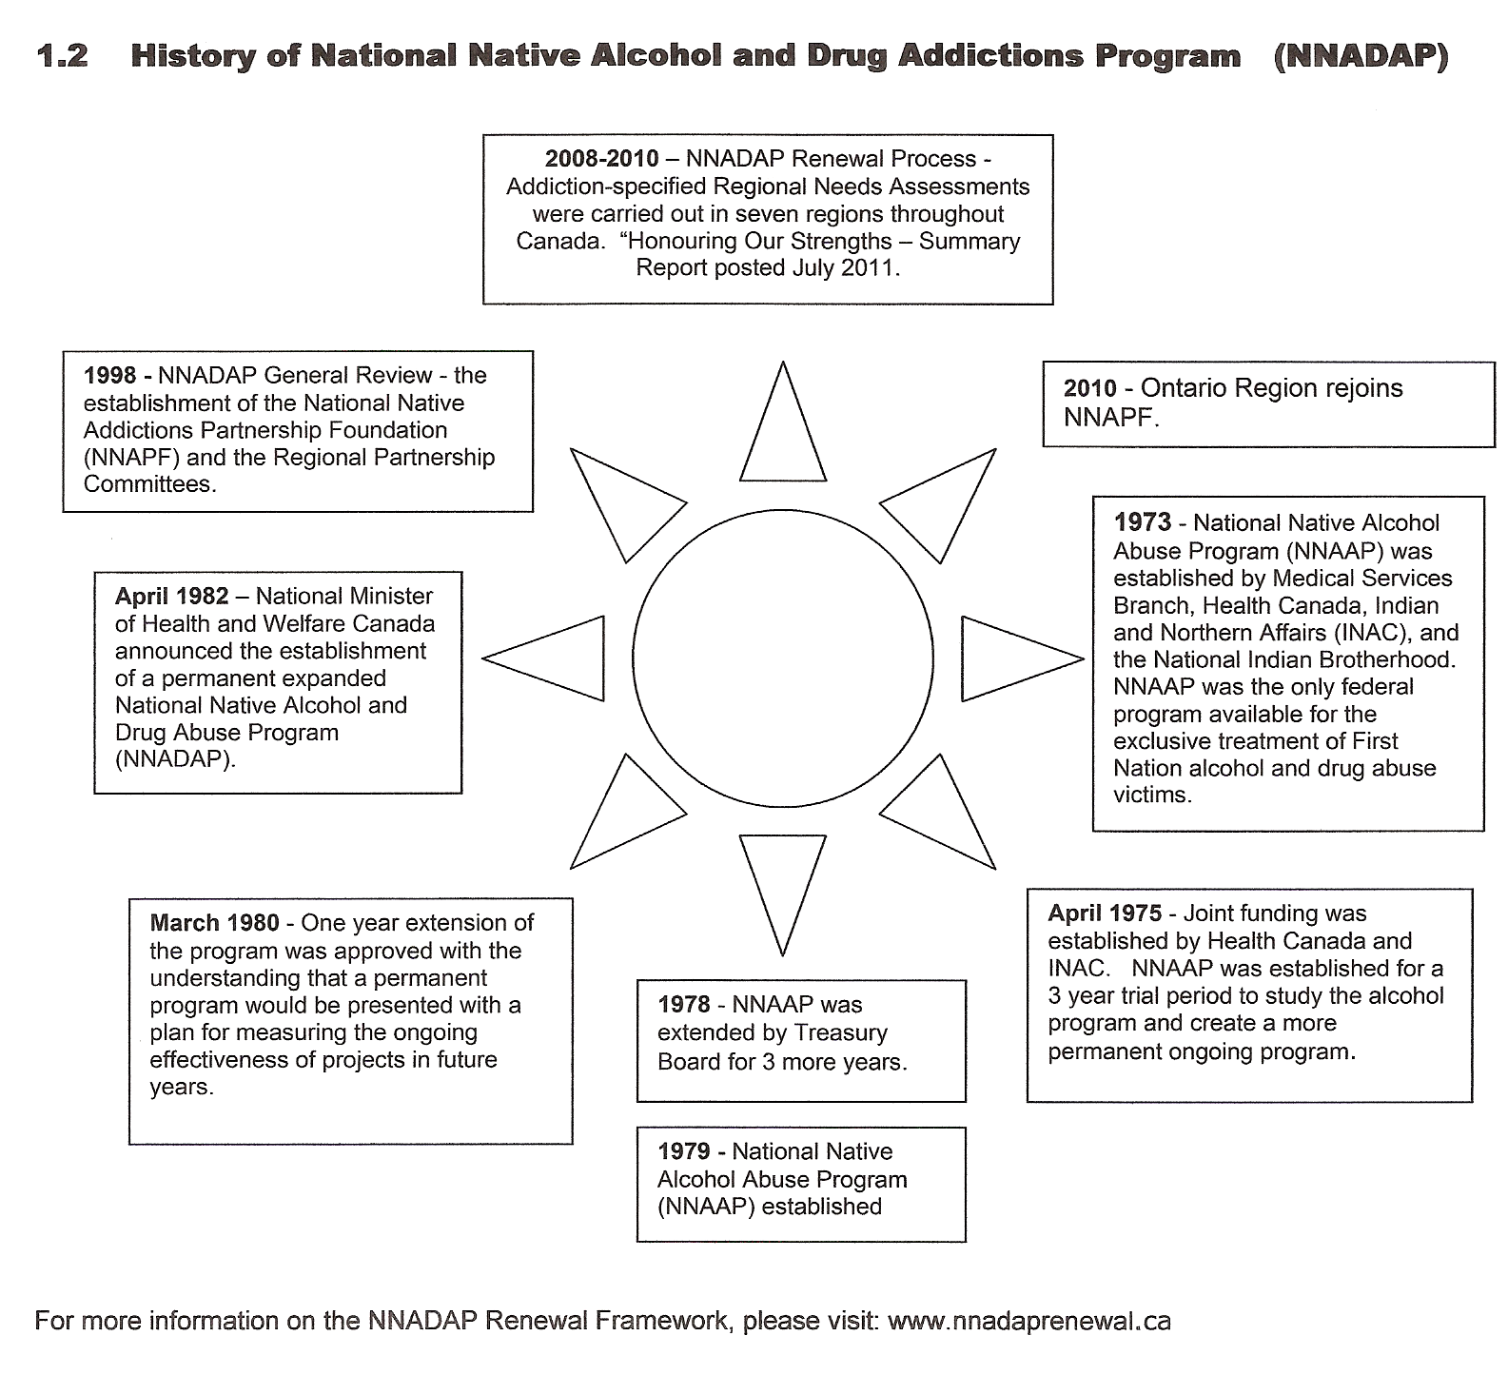

1.3 NNAPF Mandate, Vision Statement, Mission Statement
Published from National Native Addictions Partnership Foundation (http://www.nnapf.org)
The National Native Addictions Partnership Foundation (NNAPF) was established in response to the 1998 National NNADAP General Review, as were Regional Partnership Committees. The National Native Addictions Partnership Foundation includes First Nations, Inuit and Health Canada representation from all regional Committees, comprising the core membership of the National Committee. The mandate of the National Native Addictions Partnership Foundation is to oversee the implementation of the recommendations of the General Review.

Mandate
NNAPF is the national voice advocating for Inuit and First Nations culturally-based addictions services.

Vision Statement
Cultivating and empowering relationships that connect us to our cultural strengths and identity within holistic and healthy communities.

Mission Statement
NNAPF commits to working with Inuit and First Nations in furthering the capacity to address addictions and related issues.

Values and Guiding Principles
The consultations held to define the framework of NNADAP Renewal identified a set of shared values and principles to guide NNAPF implementation work.
These values inform the style of work, individual and organizational interactions and the overall direction taken by the national and regional working groups and their individual members.
They also provide the moral base for the work of management and committees guiding direct delivery, the workers providing the services, and the clients participating in our programs.
Shared values of the stakeholders represented in the partnership
Respect
Accommodating cultural Diversity
Honesty
Compassion
Trust
Family Strength
Humility
Holistic approaches reflecting the interconnectedness of causes, consequences and solutions
1.4 ORAPC Mandate, Roles and Responsibilities

Background

One recommendation of the 1998 General Review of the National Native Alcohol and Drug Abuse Program (NNADAP) indicated the need to enhance program coordination and develop a well-defined strategy for dealing with the problems posed by addictions. In keeping with the review findings and recommendations, Partnership Committees between First Nations and Health Canada were developed to bring together their expertise and knowledge of addiction treatment environments.

Ontario Regional Addictions Partnership Committee (ORAPC) Mandate
The Ontario Regional Addictions Partnership Committee Mandate is to provide advice/ guidance/ recommendations to leadership through the Chiefs of Ontario office and the First Nations & Inuit Health Branch on issues of addictions and holistic approaches to healing through an ongoing process of review and utilization of the April 2005, NNADAP Renewal Framework.
The Ontario Regional Addictions Partnership Committee (ORAPC) reports to the Chiefs of Ontario office through the Health Coordination Unit. The ORAPC members shall also provide reports to the NNADAP workers in their respective areas.

Mandate

The establishment of the Committee provides a means to facilitate communication for the implementation of the NNADAP review. The Committee will examine the recommendations and provide input on regional initiatives and national initiatives, when requested, in the area of addiction programs and services.
The Committee is to provide advice/ guidance/ recommendations to leadership through the Chiefs of Ontario office and the First Nations & Inuit Health Branch on issues of addictions and holistic approaches to healing through an ongoing process of review and utilization of the NNADAP Renewal Framework, 2008.
Structure
The ORAPC (committee) is comprised of individuals who are familiar with NNADAP services and Treatment Centre programming. The committee members are representative of the four provincial and territorial organizations (PTO’s), Independent First Nations, NNADAP-funded treatment centres and representative Transfer Payment Agency (TPA).

Accountability
The ORAPC (committee) reports to the Chiefs of Ontario office through the Health Coordination Unit. The ORAPC members shall also provide reports to the NNADAP workers in their respective areas.

The Ontario Regional Addictions Partnership Committee will:
- Review the Terms of Reference for the Committee annually.
- Develop an annual workplan to be submitted to the Chiefs of Ontario Office and FNIH. It will include and provide for the Committee’s continuing role in determining the direction of the addictions in Ontario.

Ontario Regional Addictions Partnership Committee
 | PTO |  | Telephone & Fax | Address
  Name | John
1 | Union of Ontario Indians (UOI) | John Mattson | 905-352-3767  905-352-3824 (fax)  jmattson@aldervillefirstnation.ca | Alderville Health Services  8467 County Road  P.O Box 12  Roseneath, ON K0K 2X0
2 | Union of Ontario Indians (UOI) | Shirley Mandoshkin | 705-368-3171  705-368-0293 (fax)  mandoshkins@askfn.com | Aundeck Omni Kaning First Nation  R.R. # 1  P.O. Box 21  Little Current, ON POP 1KO
3 | Nishnawbe-Aski Nation (NAN) | Vacant
4 | Nishnawbe-Aski Nation (NAN) | Francine Pellerin | 807-344-4575 ext. 228  807-344-2977 (fax)  fpellerin@matawa.on.ca | Matawa First Nations Management  233 S. Court Street  Thunder Bay, ON P7B 2X9
5 | Treatment Representative | Wanda Smith | 905-768-5144  807-768-5564 (fax)  nhtc@sympatico.ca | R.R. #1 130 New Credit Road  Site 3A, Box 6  Hagersville, ON N0A 1H0
6 | Treatment Representative | Rolanda Manitowabi | 705-859-2324  705-859-2325 (fax)  rmanitowabi@ngwaagan.ca | Ngwaagan Gamig Recovery Centre Inc.  P.O .Box 81  Wikwemikong, ON P0P 2J0
7 | Six Nations of the Grand River | Penny Hill | 519-445-2947  519-445-4388 (fax)  pennyhill@sixnations.ca | New Directions Group  P.O Box 5000  Ohsweken, ON N0A 1M0
8 | Independent First Nations-North | Vacant
9 | Independent First Nations-South | Patricia Sword | 519-627-0767  519-627-2991 (fax)  Patricia.sword@wifn.org | Walpole Island Community Service Program  R. R. 3  Wallaceburg, ON N8A 4K9
10 | Treaty 3 | Rueban Wasacase  Vacant | 807-548-5959  807-548-2084 (fax)  rmwasacase@sbellnetca | Migisi Alcohol and Drug Treatment Centre  P.O. Box 1340  Kenora, ON P9W 3X7
11 | Association of Iroquois and Allied Indians (AIAI) | Valerie George | 519-652-0500  519-652-0638 (fax) valerie.george@oneida.on.ca | Oneida Human Services  2213 Elm Avenue  Southwold, ON N0L 2G0
12 | Transfer Payment Agency (host) Representative | Yvonne Wright | 519-627-0767  519-627-2991 (fax)  Yvonne.wright@wifn.org | Walpole Island First Nation  Walpole Island Community Service Program  R. R. 3  Wallaceburg, ON N8A 4K9

Published from National Native Addictions Partnership Foundation (http://www.nnapf.org
Published from National Native Addictions Partnership Foundation (http://www.nnapf.org)

