
Chapter 5
SKILLS DEVELOPMENT

The Serenity Prayer
God grant me the serenity
To accept the things I cannot change,
The courage to change the things I can,
And the wisdom to know the difference."

5. SKILLS DEVELOPMENT
5.1 ORAPC Training
5.2 Planning for Effective Workshops
5.3 Developing Your Interviewing Skills
5.4 Educational Institutions offering Training in Addictions

5.1 ORAPC Training
The General Review of NNADAP, as well as the recent Health Strategies promoted by the Federal Government and Aboriginal National organizations recognizes that training and accreditation of Aboriginal professionals working in the field of Addictions is a need and a priority.
Since 2006, the ORAPC Committee has accessed funding and coordinated a number of training opportunities for NNADAP workers as a means capacity building for training and professional development. ORAPC has also gathered information regarding training needs and has developed a five year training plan. ORAPC’s five-year Strategic plan and Training Strategy includes specific activities to do this, in particular the hosting of Annual Training Conference. ORAPC does request funding to host a Conference to provide training for NNADAP workers annually.
ORAPC does not fund individual requests for training although we access funding for regional training initiatives. ORAPC has gathered data indicating that the majority of workers would meet the required competencies for certification. Ongoing resources will be needed to ensure continuity of professional development in the field of addictions which is constantly evolving.

5.2 Planning for Effective Workshops
The following information is a guide that can be used when planning a full day workshop or conference.

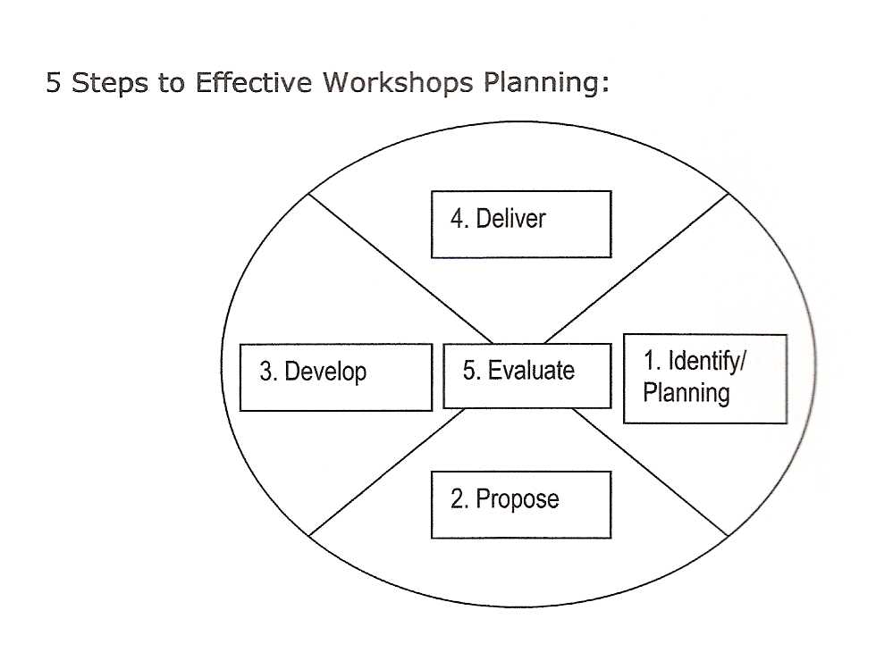
Identify/Planning

- Purpose of the workshop and who will be the audience;
- Strengths and challenges to deliver a workshop
- Who will be the audience, consider budget, time and how will success be measured

___ month(s) prior to the workshop:
- Research different workshop sites and service providers for food and/or supplies.
- Meet with all parties required to brainstorm workshop needs
      - Who will be the lead person of the workshop
      - What are the possible goals and objectives of the workshop
      - When, possible dates and set date and time(s)
      - Location and who will reserve room(s) for workshop(s), attendees and presenters

1. Identify /Planning
Workshop/Conference | Contacted by | Date completed
Date:
Location:
Target Group:
Presenter(s)

2. Propose
- Describe what the learning objectives are
- Describe the needs that will be met
- Brainstorm content and learning of the workshop
- Number of expected participants
- Estimate cost or budget for workshop(s)
- Send out a request for a proposal or call workshop sites and service providers to submit proposal- hotels, caterers, office supply companies
- Review each proposal as to how they will meet your specific needs.

Appendix G of the Templates contains examples of Effective Workshop planning documents: Identify /Planning, Proposed Budget, Workshop Site planning, Meal Requirements, Registration form, Participant/Registration List of information.
.
- Consider meeting room needs, presenter needs and accommodation needs.
- Consider topics and possible presenters
- Prepare presenters’ profile consisting of contact information, presentation description, travel requirements and expense costs.
- Consider meal refreshments requirements.
- Plan menus with staff or caterer involved.
- Remember the little things i.e. condiments, dishes, cups, serving spoons, etc.

- Develop
- Develop a registration form
- Develop a participant/registration list of information

Before workshop
- Pay deposits as required on facility/hotel
- Locate Elder, drum, medicines
- Contact caterer and pay deposit for meals as required
- Order equipment for presenters
- Develop an evaluation form
- Prepare materials for workshop
- Make copies of certificates
- Name tags labeled
- Participant’s folders labeled
- Assemble information for copying on computer (USB)
- Collect registration fees
- Request final payment for presenter, site manager, caterer, office supplies, travel
- Make bank deposits
- Allocate/ assign staff for presenter introductions and closure
- Assign registration desk staffing
- Check in for refreshments, snack and meals with caterer
- Arrange folders, name tags, conference information in folders
- Purchase gifts
- Follow up with Elder, drum

4. Deliver
- provide workshop with professionals, community/Elders
- finalize payments to presenter, site manager, caterer, office supplies, travel agency, other

5. Evaluate
- gather participant evaluations
- collocate results from evaluations
- complete budget and follow ups required
- print copies of certificates
- complete report summary of workshop
- report results of the evaluations, strengths, recommendations and challenges
- distribute report, final budget and certificates to all parties involved
5.3 Developing Your Interview Skills

It is understood that prior to beginning any interview, assessment or counselling session, the counsellor has explained their expected client behaviour and has informed their client that threatening or hostile behaviour will not be tolerated in this process. Each community should have clear policies that are explained to your clients prior to beginning an interview (especially around sobriety or ability to understand the information, client’s rights and responsibilities).

The interview may have several different purposes. Collecting information is a very important aspect of an interview. The structure of each interview should be consistent from one client to the next, so you can develop the skill of probing for personal information in a kind, caring, and consistent way. Both the counsellor and their client need to be clear about the purpose of their interaction at the interview. It is to:
- build rapport with your client to develop trust and understanding
- conduct an objective assessment of their substance use
- collect general intake information to be discussed
- examine the impact of their substance use in a variety of their life areas
(mental, emotional, spiritual, social, physical, legal, and financial or...)
- examine your client’s perception of their risks, problems and consequences to provide personalized information to help your client develop an understanding of their role in this situation.
- give your client an opportunity to clearly compare their substance use patterns and consequences to that of the general population. This comparing normalizes their addiction and increases your client’s information about what responsible substance use looks like.
- provide an opportunity to educate your client about concepts and issues such as:
• tolerance
• harm reduction
• continuum of use, misuse, abuse and dependence
• withdrawal symptoms
• dangers of intoxication to their health
- provide an opportunity to affirm and support your client for the changes they have made, the amounts they have reduced use, etc
- can be an opportunity to evaluate your client’s use of each drug separately. Your client may be struggling with one or more drugs, but using another substance as prescribed, or within safer limits.
- provide sensitivity to the needs of your client and their emotional, physical and psychological functioning at that time. A good counsellor is aware that their interviews must accommodate the differences of their client’s needs from their own personal needs.

The counsellor may conduct their interviews in a variety of settings; if it will assist you in completing a good interview. Your counselling session can be informal or formally conducted in an office at an allotted time. Your client needs to understand your role, limitations, strengths and relationships with other agencies. You can use any personally designed format or group structure to do your work.
There will be times when you must shorten the amount of allotted time for an interview especially when working with a senior or youth. Take a break, when your judgement tells you that your client will focus better later. If the task at hand seems too difficult, don’t be afraid to set it aside and return to it later.
The interview allows the counsellor an opportunity to collect all the necessary data, so that the client and the counsellor can together develop goals and determine their next steps.
The counsellor uses their own personal format to develop the purpose of the interview, and any other elements such as your client’s present, personal circumstances; which are the keys to a positive interview experience.

5.4 Educational Institutions offering Training in Addictions
1. Algonquin College Addictions Studies
http://www.ontariocolleges.ca/portal/page/portal/ONTCOL/SearchResult/ALGONQUIN/_/N-1z141xr?metaTagParam=algonquin-college&cm_re=algonquin-02-09-_-body-_-find-body

2. Brock University Drugs and Behaviour Addiction (Psychology)
https://experience.brocku.ca/Program/Index.aspx

3. Center for Addiction and Mental Health Continuing Education
http://www.camh.net/education/index.html

4. Cambrian College Alcohol & Drug Dependencies Intervention Counselling
http://www.cambriancollege.ca/PROGRAMS/Pages/ProgramsPrograms.aspx

5. Canadore College-Seven Generations Education Institute Indigenous Wellness and Addiction Prevention and Drug and Alcohol Counsellor Program
http://www.canadorec.on.ca/ProgramInfo/FullTime/HumanServices/index.cfm

6. Centennial College Addictions Studies
http://www.centennialcollege.ca/Programs/

7 .Confederation College-Negahneewin Indigenous Wellness and Addictions
http://www.confederationc.on.ca/programs/all

8. George Brown College Human Services Counsellor Program
http://coned.georgebrown.ca/

9. Georgian College-Orillia Addictions Treatment and Prevention Diploma
http://www.georgianc.on.ca/coned09/coursescertificates/?f=display_courses&p_cat_code=ADTP&p_keyword=Addictions:%20Treatment%20and%20Prevention&p_url=Health%20Sciences

10. Mc Master University Addictions Studies/Addiction Care Worker and
Canadian Problem Gambling Counsellor
http://www.mcmaster.ca/conted/med/pdf/Timetable.pdf

11. Mohawk College of Applied Arts- Native Community Care Counselling and
Development
http://www.mohawkcollege.ca/continuing-education/human-services/#

12. Niagara College
http://www.niagaracollege.ca/programs/programs_alpha_conted_programs.htm

13. Northern College Aboriginal Programs- Native Counsellor
http://www.northernc.on.ca/docs/Web_Calendar.pdf

14. Six Nations Polytech Institution
http://www.snpolytechnic.com/programs.html

15. Ryerson University
http://ce-online.ryerson.ca/ce/calendar/default.aspx?id=5&section=course&sub=subject

16. Sault College of Applied Arts and Technology
http://www.ontariocolleges.ca/portal/page/portal/ONTCOL/ProgramDetail?Ntk=ProgramCode&Ntx=mode+matchall&Ntt=1214&N=4294965824

17. St Clair College of Applied Arts and Technology-
Chemical Dependency Counselling Program
http://www.stclaircollege.ca/programs/postsec/native_comm/

18. University of Toronto- Alcohol, Tobacco and Other Psychoactive Substances and Collaborative Graduate Program in Addiction Studies
http://www.utoronto.ca/programs.htm

19. York University/Atkinson College- Alcohol and Drug Dependence
http://dce.yorku.ca/

20. Athabasca University
http://www2.athabascau.ca//course/search.php

21. First Nations Technical Institute
http://www.fnti.net/post-secondary-partners/
Provides training through the following institutions:
Social Service Worker - St. Lawrence College
Bachelor of Social Work - Ryerson University
Master of Social Work - Aboriginal Field of Study - Wilfred Laurier University

22. Oshki-Pimache-O-Win/Nicola Valley Institute of Technology- Chemical Addiction Worker Program
http://www.nvit.ca/programsandcourses.htm?RD=1

Online Education: Learn from Your Workplace or Home!
1. CAMH offers facilitator-led online courses, which you can participate in from any computer with Internet access. People with all levels of computer expertise can take these courses – the technology is user–friendly and easy to master, and support is available if you need it. The courses run for approximately eight weeks, and they require a minimum time commitment of four hours per week. They provide a collaborative learning environment, where you will read through course content and engage http://www.camh.net/education/Online_courses_webinars/index.html
2. Brown’s University, USA
Provides certification that meets Canadian standards at Walden University and University of Phoenix.
http://www.e-onlinecolleges.net/jcanadian2.php

3. Walden University
To learn more about Walden degree programs and how they are helping adult learners make a positive change, visit their website at:
http://www.e-onlinecolleges.net/uopform.php?flag=campus
Bachelor of Science (B.S.) in Health Studies - Health & Cultural Diversity
Bachelor of Science (B.S.) in Health Studies - Health Psychology and Behaviour

b) University of Phoenix Complete coursework through electronic forums, receive lectures, questions and assignments from your instructor electronically. Study them at your convenience; log on at least four days per week for University of Phoenix classes. You choose the days and times, and build teamwork skills by collaborating on additional assignments with a learning team.
http://www.e-onlinecolleges.net/jcanadian2.php
4. Nechi Institute, Alberta -Community Addictions Training (CAT) and Advanced Counsellor Training (ACT)
http://www.nechi.com/programs/indigenous-addictions-services-certificate-iasc
5. TAPE Studies
http://www.tapestudies.com/otheronline.jsp

