
Chapter 8
PROMOTION AND PREVENTION
Lakota Instructions for Living
Friend do it this way - that is,
whatever you do in life,
do the very best you can
with both your heart and mind.
And if you do it that way,
the Power Of The Universe
will come to your assistance,
if your heart and mind are in Unity.
When one sits in the Hoop Of The People,
one must be responsible because
All of Creation is related.
And the hurt of one is the hurt of all.
And the honor of one is the honor of all.
And whatever we do effects everything in the universe.
If you do it that way - that is,
if you truly join your heart and mind
as One - whatever you ask for,
that's the Way It's Going To Be. Passed down from White Buffalo Calf Woman

8. PROMOTION AND PREVENTION
8.1 Prevention Services and other Treatment Program Services (chart)

8.1 Prevention Services and other Treatment Program Services (chart)
The following Prevention Services and other Treatment Program Services chart provides a visual aid for clients and staff to see the NNADAP agency’s services and the process to follow for a client’s prevention and treatment process. Each agency needs to develop a chart for program consistency and coordinated services.

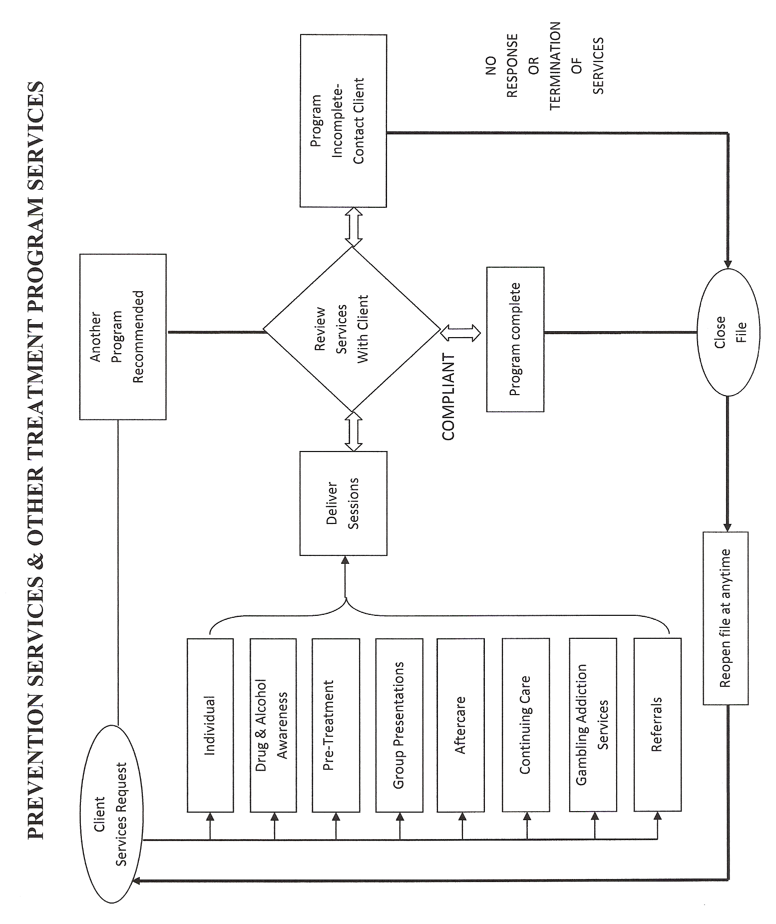

Developed by Ngwaagan Gamig Recovery Centre Inc.(Rainbow Lodge)

