
Chapter 10 TREATMENT
Cherokee Saying
One evening an old Cherokee told his grandson
about a battle that goes on inside people.
He said: “My son, the battle is between two
“wolves” inside us all.
One is Bad.
It is anger, envy, jealousy, sorrow, regret,
greed, arrogance, self-pity, guilt, resentment,
inferiority, lies, false pride, superiority, and ego.
The other is Good.
It is joy, peace, love, hope,
serenity, humility, kindness, benevolence,
empathy, generosity, truth, compassion, and
faith.
The grandson thought about it for a minute and
then asked his grandfather:
“Which wolf wins?”
The old Cherokee simply replied:
“The one you feed.”

10. TREATMENT
10.1 Detoxification Processes
10.2 Treatment Centre Intake Process
10.3 NNADAP Standardization of Forms
10.4 NNDAP Client Intake Form
10.5 Youth Solvent Abuse Committee (YSAC) Youth Referral Form for Treatment
10.6 Family Healing Program Referral Form
10.7 Client Participation Contract
10.8 Family Participation Contract
10.9 Medical (Adult) Assessment Form
10.10 Child-Youth Medical Assessment Form
10.11 Referral Worker’s Assessment

10.1 Detoxification Processes

Detoxification is a process in which people addicted to drugs or alcohol, are cleansed of the toxins created by those substances either by traditional (sweatlodge, herbal, etc.) or western medicines. "Detoxification" or 'detox' refers to the period of time it takes for the 'active' toxins to leave the body. This can be as little as a week or as long as several months. Appropriate medications are available for detoxing from opiates, benzodiazepines, alcohol and barbiturates. In some cases, particularly for different types of drugs, detoxing may be a medical necessity, and untreated withdrawal may be medically dangerous or even fatal.
Detoxification, or detox, is most often the first step in the rehabilitation process for addicts and alcoholics. The withdrawal/detoxing process begins when the ongoing use of drugs and/or alcohol stops abruptly. Your client’s withdrawal symptoms are generally the opposite of the effects produced by the substance they used. Your client’s symptom severity varies based on several factors:
1. the type of substance
2. frequency of use
3. regular dosage
4. duration of use (how many weeks, months or years the user has been using the substance)
5. physical health of the user
6. mental and emotional state ("attitude")
Before an addicted client can be admitted into a treatment centre program, they must first complete the detox process. There are many different types of detoxification processes depending on the substance of dependence, traditional vs. western and the severity of the addiction.
The Detox Process
There are mainly three steps involved in drug and alcohol detoxification:
1. Evaluation – Your client is first tested and evaluated for detox. Mental health issues and a holistic evaluation need to be conducted to help evaluate your client’s underlying issues.
2. Medical Stabilization – This can be done with or without medication, but in most cases, medication is necessary to help stabilize your client and treat their withdrawal symptoms.
3. Guiding your client to the wellness program/treatment centre– The next step is the recovery process itself, usually involving continuing on in an alcohol/drug rehabilitation program?
There are some drugs of abuse that do not necessarily create a particularly significant psychological dependence and do not require medical detoxification, such as methamphetamines, cocaine, and marijuana. The abuse of these drugs can result in a serious psychological dependence which often requires intense therapy and residential treatment, but not always medically assisted detox.
Nevertheless, detox protocols need to be established for each of the substances used by your clients from your employer. Other drugs such as heroin, alcohol, and prescription medications like opiates, barbiturates and benzodiazepines create not only a psychological, but also a serious physical dependence, requiring medical detoxification in most if not all cases of long-term use.

Alcohol Detoxification
Alcohol is one of the most dangerous drugs of abuse, not only because of its availability and social acceptance, but also because of its damaging effects and dangerous detox. Many alcoholics who try to stop drinking on their own experience uncomfortable and even dangerous withdrawal symptoms, and in the worst cases, these symptoms can be fatal. During alcohol detoxification, your client should be medically monitored during the withdrawal of the alcohol from their system. During this process, an alcoholic client may experience anywhere from mild to severe withdrawal symptoms such as sweating, headaches, anxiety, increased heart rate, insomnia, agitation, and delirium tremens (DT’s) leading to seizures and sometimes even death. At a medical detoxification program, medical staff will use various medications to ease the most severe symptoms of alcohol withdrawal. The detox process can last several weeks to months of medical care. Most cases of alcohol detoxification, however, take anywhere from 3 to 10 days.

Opiate Detoxification
Heroin and opiate based pain killers (Vicodin, Percocet, Darvon, Morphine, Fentanyl, OxyContin, Methadone) not only cause a psychological addiction, but also a physical addiction that makes the detoxification process especially difficult. Detoxification of opiates from the body is a process that often involves other drugs being administered to make the process more tolerable. Some of symptoms of opiate withdrawal are nausea, vomiting, diarrhea, high fever, cold sweats, shaking, muscles spasms, insomnia, extreme fatigue, and muscle aches. Because the pain and discomfort is so severe in many cases of opiate withdrawal, addicts are often given benzodiazepines like Valium to "take the edge off" and help a client to relax and hopefully sleep through the detoxification process. These drugs have very long half-lives, so when the effects of them wear off, the user experiences less severe withdrawal symptoms than from their drug of choice. The detoxification of opiates from the body, takes anywhere from 3-10 days, and thereafter a period of time when the recovered user may experience mild depression, lethargy, and fatigue, and other withdrawal symptoms, known by PAWS (Post Acute Withdrawal Syndrome- see below).
Another form of medical opiate detoxification is rapid opiate detox, in which doctors anesthetize the client, administer a combination of opiate antagonist medications that send the client into immediate acute withdrawal for several hours while under anesthesia, until the opiates are out of their system. Clients are usually monitored in the hospital overnight and then sent home within 1 day of this procedure.

Benzodiazepine Detoxification
Benzodiazepines (Xanax, Ativan, Valium and Klonipin) are drugs classified as mild tranquilizers, which act as depressants, slowing brain function and relaxing muscles. The prolonged use of these drugs can lead to extreme physical dependence, which makes the detox process very dangerous. Generally, when clients addicted to benzodiazepines begin detox, they can experience sleep disturbances and insomnia, irritability, headaches, fatigue, sweating, anxiety, and seizures. The withdrawal process generally creates the very symptoms that benzodiazepines are used to treat. Until the toxins from benzodiazepine abuse have been completely removed from the body, it is important for the client to remain under medical care. The cessation of benzodiazepine use can cause dangerous and sometimes deadly seizures until the drug is out of their body. For some of the drugs in this class, the toxins can remain in their body for as long as 4-6 weeks depending on the severity and length of the abuse.

Detoxification from Cocaine, Methamphetamines, and Other Stimulants
Detoxification from stimulants like cocaine, crack, cocaine and meth can be psychologically grueling. Detoxifying the body of these kinds of drugs can cause significant psychological withdrawal symptoms including anxiety, irritability, insomnia, severe cravings and fatigue. Detoxification from methamphetamine specifically can cause psychotic reactions, severe depression, and confusion. The most common detox medications used to treat stimulant withdrawal are antidepressants and mood stabilizers. The detox process can last anywhere from 3 to 10 days.

Acute Abstinence Syndrome

When a substance user’s drug levels drop below a certain point they will experience symptoms of the Acute Abstinence Syndrome (AAS). AAS is what causes an addict to use again within a very short period of time, after their first use, “Chasing the High”. They must maintain their drug/alcohol high or they will experience withdrawal symptoms. These symptoms may include: fatigue, confusion, disturbed sleep, increased dreaming, depression, anxiety, anger, dysphoria (abnormal feeling of dissatisfaction, depression, restlessness, or fidgeting) or stress.
During this period there is a need for several different types of treatment. A treatment program is needed to help your client work through the depression, fatigue, confusion, sleep disturbance, increased dreaming, anxiety, anger, dysphoria and stress. During their treatment process, your client will need to receive individual attention, learn pain management skills, train in stress management, and receive reassurance that what is happening is normal, predictable, and will end soon. As your client goes through the AAS period, you will find that physical activities, support from their community, individual attention, and personal involvement in their treatment will be crucial in their recovery. Keeping it simple and helping them understand what this process means is a key to acceptance and change from their addiction.

Post Acute Withdrawals (PAW):

During substance abuse at the chronic stage, your client must maintain a certain level of drugs in their system or he/she will experience withdrawal called the Post Acute Abstinence Syndrome. Post Acute Withdrawal emerges after 5-7 and 20-30 days into abstinence. Post Acute Withdrawal symptoms include anxiety, depression, irritability, sleep disturbance and compulsiveness.

Recovery from nervous system impairment requires abstinence, but the neurological impairment interferes with your client’s ability to abstain. There is a direct relationship between elevated stress and the severity of PAW. Each intensifies the other. Recovering addicts can learn to manage PAW by proper diet, exercise, relaxation and life management skills. The symptoms of PAW will pass with continued sobriety. What is learned while drinking and using drugs is most easily recalled while at the same blood alcohol/drug level. This is called state dependent learning. In sobriety, your client may have difficulty remembering how to perform many tasks they learned while drinking or using. Skills that are learned while using are easily relearned. Sobriety based denial may cause your client to avoid doing those things that are necessary for their recovery. If your client experiences cravings, they should avoid people and situations that would make it easy to use again. Conflicts may arise between a character style that supported drinking and/or using and a personality style necessary for recovery. The dream state of sleep (REM) is necessary or emotional and thought distortions will occur. During their abstinence the body will catch up on dream sleep (REM) missed while your client was using. As the body seeks to catch up on sleep, nightmares and restlessness will occur. Your client needs to learn a new way of living that enables them to adjust to and overcome the limitations imposed by the effects of drug and alcohol addiction that persist into recovery.

The detox process, which is often short-term, is not designed to deal with the psychological, social, emotional, spiritual and behavioral problems associated with addiction. Therefore, it most often does not produce the lasting behavioral changes necessary for recovery. Detoxification that is most useful and that has the greatest chance of making a long-term difference is one that incorporates an assessment and referral process to a community treatment program. For more information go to eHow Health at:
http://www.ehow.com/about_4761191_alcohol-detox-symptoms.html
For listing of Medical Detoxification Centres see chapter 12

Please note that the counsellor needs to check with the detoxification centres protocol to fit with your client’s withdrawal needs.

10.2 Treatment Centre Intake Process

The Treatment Centre Intake Process Chart is a visual diagram showing how a treatment centre could function upon receiving a NNADAP referral. Each community treatment program should develop a referral process chart for their unique treatment centre process which can avoid confusion as to how the treatment functions and to assist with staff consistency and accountability and client knowledge of the intake process.

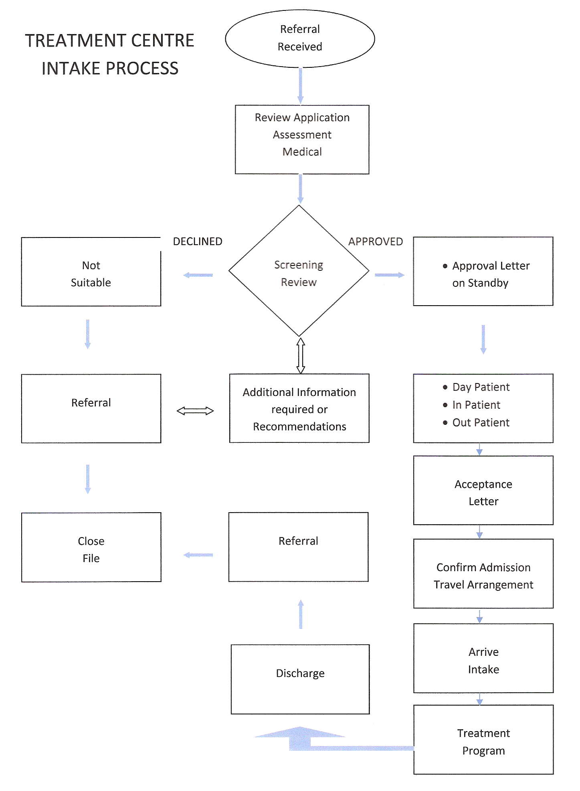
10.3 NNADAP Standardization of Forms
ORAPC’s vision is to develop the Standardization of Forms that can be used and accepted by all NNADAP Treatment Centres and workers in Ontario. There are a number of advantages to the clients, counsellors and treatment centres to using standardized forms:
- Efficiency- only necessary information is gathered for decision making
- Consistency- no matter where a client enters the system the same information is required
- Useful information gathered that provides useful feedback
- forms and understands the needs of each other
- Less duplication of forms and paper time required for completion
- Credible process establishes client trust and organization credibility

The following forms: NNDAP Client Intake Form, Family Healing Program Referral Form, Client Participation Contract, Family Participation Contract, Medical (Adult) Assessment Form, Child-Youth Medical Assessment Form and Referral Worker’s Assessment can be used by the community and also the treatment centres to work towards standardization.

10.4 NNDAP Client Intake Form

This NNADAP Client Intake Form is designed to provide basic information that can help the counsellor generate a client intake profile that can be used for all treatment centres and NNDAP workers. The information gathered on this form is a collaboration of intake information that was gathered and synthesized into one form to meet the needs of all agencies. This form allows the counsellor an opportunity to note all of the relevant information regarding their client. Their areas of strength and need can be identified. The additional information that is collected during this initial intake process is noted, creating a clinical profile of your client.
A copy of the NNDAP Client Intake Form is located in Appendix R.

10.5 Youth Solvent Abuse Committee (YSAC) Youth Referral Form for Treatment

The Youth Solvent Abuse Committee (YSAC) is a network of First Nations National Solvent Abuse Residential Treatment Centres in Canada. This unique group works together with a shared vision; but are able to maintain and function as individual treatment centres. The committee meets at various locations in Canada quarterly to provide strategic planning, collaborate on research and prevention efforts and define the best practices for solvent abuse treatment.
There are two solvent abuse centres in Ontario- Nimkee Nupigawagan Healing Centre which provides residential treatment for youth between the ages of 13-17 who abuse solvents and other substances and Ka Na Chi Hih Solvent Abuse Centre which provides residential treatment for male youth between the ages 16-25. Both solvent abuse centres have programs that provide cultural activities.

A copy of the YSAC Youth Referral Form is located in Appendix S. This Referral Form can be used when making a youth referral to any Solvent Abuse Centre in Canada.

10.6 Family Healing Program Referral Form
The Family Healing Program Referral Form was synthesized from information gathered from the family healing program. This form can be used to help the counsellor generate a family profile. It allows the counsellor an opportunity to note all of the relevant information regarding their client family’s strengths and needs. The additional information that is collected during this initial process can be used to create a clinical profile of the family. The following Family Treatment Centres will be utilizing this form for admission to family treatment at Sagashtawao Healing Lodge, Native Horizons or Reverend Tommy Beardy Memorial Family Wee Che He Wayo-Gamik Treatment Centre.

A copy of the Family Healing Program Referral Form is located in Appendix T.

10.7 Client Participation Contract
Many times clients attending a treatment or counseling program are not aware of the expectations of their wellness program. The following form is an example of some client participation expectations that should be reviewed with your client to ensure both the client and counselor are aware of the expectations at each session. This is an optional form that may be adapted to meet your client’s needs in regard to attending and participating in wellness program/sessions.
See Appendix U for a copy of the Client Participation Contract.

10.8 Family Participation Contract
The Family Participation Contract is an agreement between the family members, referral workers and the treatment staff to ensure that all family members actively participate in all aspects of the wellness program provided. A copy of this form is required in the Referral Package sent to family treatment centres. This form can be adapted to meet the needs of community based family programs as well as treatment programs.

A blank copy of the Family Participation Contract is located in Appendix V.

10.9 Medical (Adult) Assessment Form
The Medical (Adult) Assessment Form is designed from the information gathered from all the treatment centres to provide consistency and less duplication. In order to provide quality care and knowledge of a client’s impending health issues; all treatment centres require complete and accurate information as possible. With the recent increases in infectious diseases and to provide health safety for all clients and staff; a TB test is a requirement prior to treatment at all treatment centres. If a client’s TB test results are positive; a chest x-ray is also required. Completion of this form is a requirement prior to admission to treatment and needs to be submitted with a client’s Referral Package.

A copy of the Medical (ADULT) Assessment Form is located in Appendix W.

10.10 Child-Youth Medical Assessment Form

The Child-Youth Medical Assessment Form is designed from the information gathered from all the treatment centres to provide consistency and less duplication. The Child-Youth Medical Assessment Form must be completed for each child-youth attending family or solvent abuse treatment. In order to provide quality care, required family needs and knowledge of a child-youth’s impending health issues; all treatment centres require complete and accurate information as possible (All medical assessments must be printed clearly in English only). With the recent increases in infectious diseases and to provide health safety for all clients and staff; a TB test is a requirement prior to treatment. If a client’s TB test results are positive; a chest x-ray is also required. Completion of this form is a requirement prior to admission to family treatment at Sagashtawao Healing Lodge, Native Horizons or Reverend Tommy Beardy Memorial Family Wee Che He Wayo-Gamik Treatment Centre and solvent abuse treatment at- Nimkee Nugigawagan Healing Centre and Ka Na chi Hih Solvent Abuse Centres. This form needs to be submitted with each client’s Referral Package.
A copy of the Child-Youth Medical Assessment Form is located in Appendix X.

10.11 Referral Worker’s Assessment
This form was developed to assist NNADAP/referral workers in preparing clients for treatment. This form should only be completed by the Referral Worker prior to a client attending a treatment program to assess their client’s needs and to ensure that all the necessary information/documentation needs are met.
A copy of the Referral Worker’s Assessment is located in Appendix Y.

Developed by Ngwaagan Gamig Recovery Centre Inc.(Rainbow Lodge)

